1.Maximum Subarray:
#code:
class Solution {
public int maxSubArray(int[] nums) {
int maxSum = nums[0];
int currentSum = nums[0];
for (int i = 1; i < nums.length; i++) {
// Either continue the current subarray or start a new one from the current element
currentSum = Math.max(nums[i], currentSum + nums[i]);
maxSum = Math.max(maxSum, currentSum);
}
return maxSum;
}
}
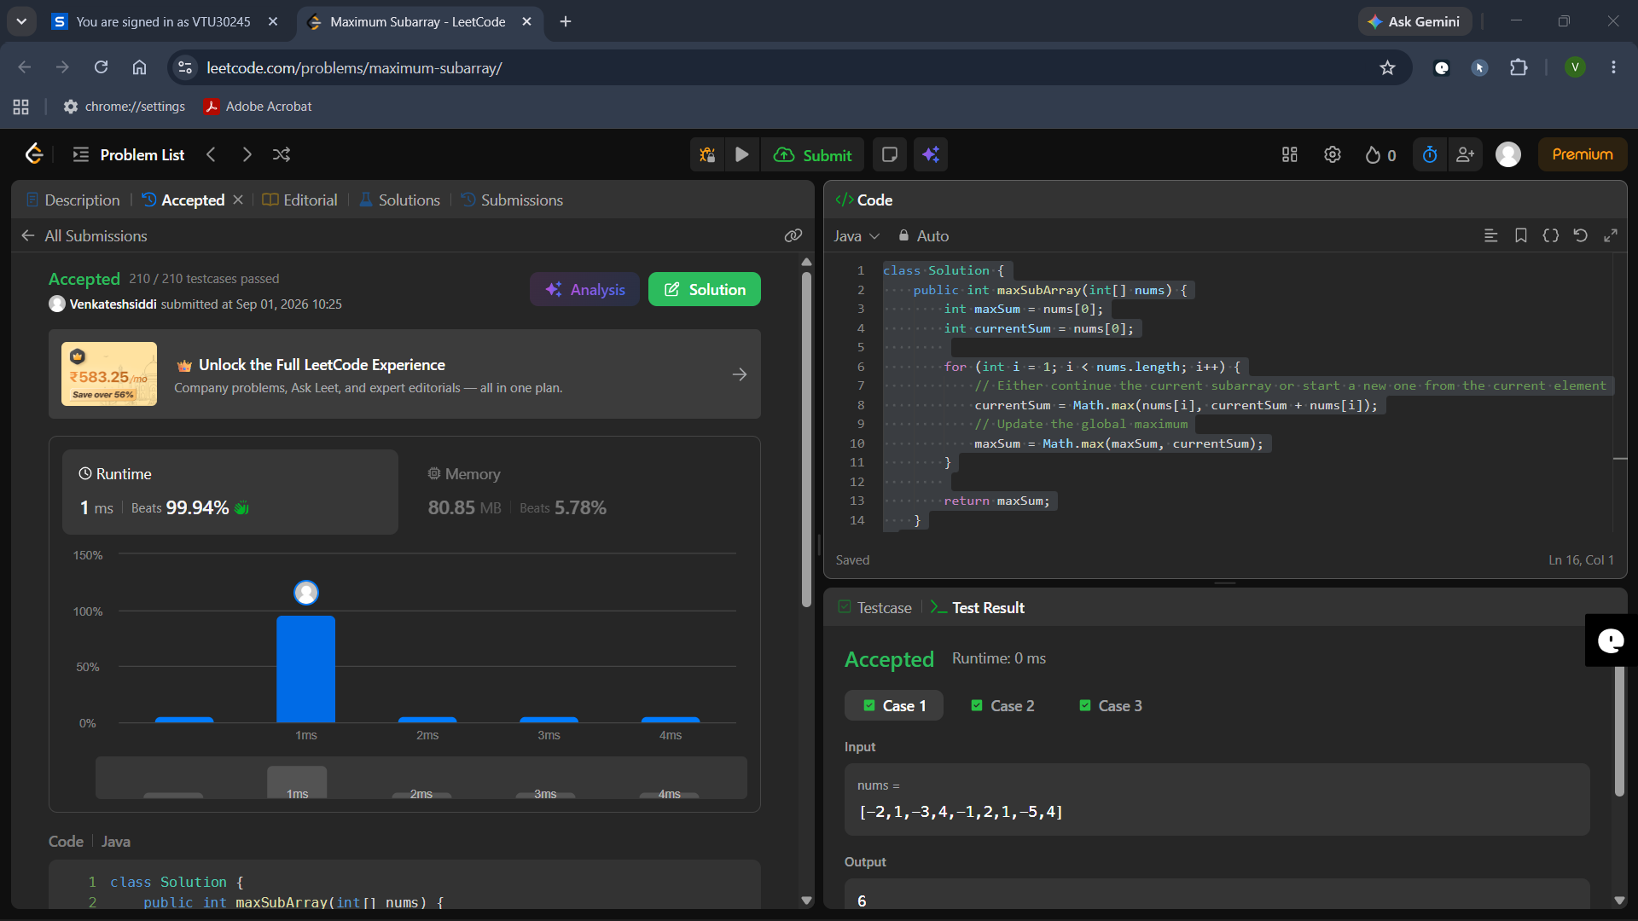

2. Find the Highest Altitude:
#code:
class Solution {
public int largestAltitude(int[] gain) {
int maxAltitude = 0;
int currentAltitude = 0;
for (int g : gain) {
currentAltitude += g;
if (currentAltitude > maxAltitude) {
maxAltitude = currentAltitude;
}
}
return maxAltitude;
}
}
